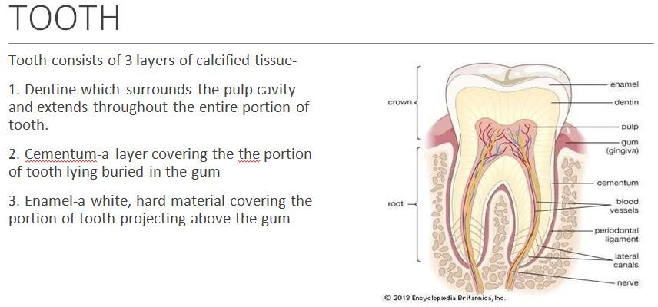

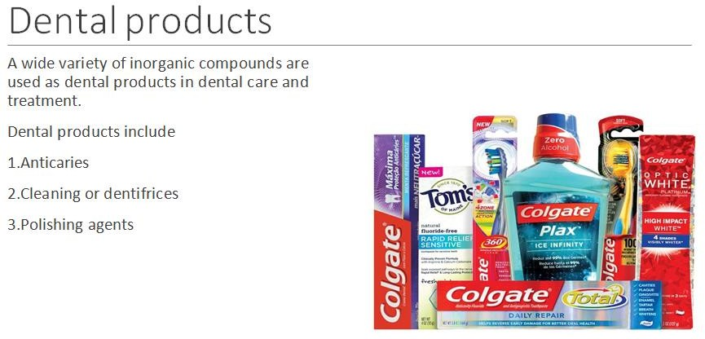

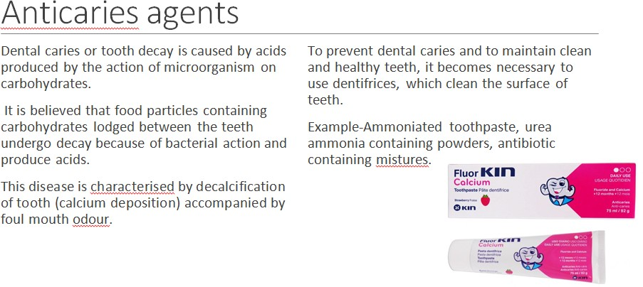

Cleaning agents or dentifrices
A dentifrice is a substance used with a tooth brush for the purpose of cleaning the surface of teeth. It is available in the form of pastes and powders. Many dentifrices contain flavours and soap or detergent.
The powders and pastes contain abrasive such as calcium carbonate, calcium sulphate, insoluble sodium metaphosphate, hydrated aluminium oxide, magnesium carbonate and phosphates, sodium bicarbonate and sodium chloride
Toothpaste contain liquids such as glycerine, propylene glycol, sorbitol solution, water, alchol and thickening agents such as starch, tragacanth, algin and cellulose derivatives.
Example-Calcium carbonate, Calcium phosphate dibasic and tribasic, Sodium metaphosphate

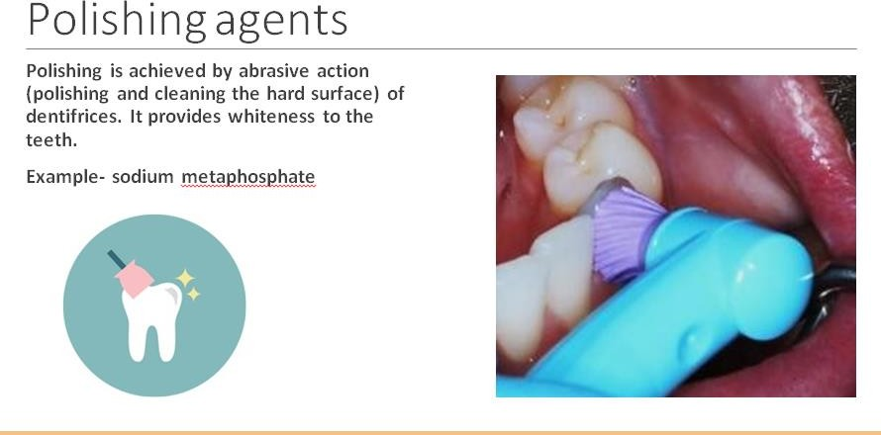
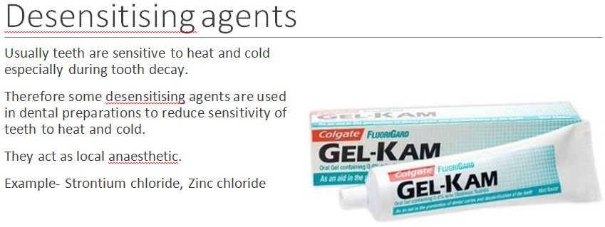

Role of fluoride
Fluoride ion is a trace material which occurs in our body. It is generally adequated in food and water. In some parts of world, ground water is totally lacking fluoride. In such places dental caries is a common problem.
Addition of fluoride to the municipal water supply, known as fluoridation is able to help in reducing and preventing dental caries.

But this is not true because those who take continue ingestion of fluoride may suffer from mottling of teeth (excess fluoride in teeth), increased density of bones, gastric problem, muscular weakness and even heart failure.
When a fluoride having salt or solution is taken internally, it is rreadily absorbed, transported and deposited in the bone or developing teeth and the remaining gets excreted by kidneys. The deposited fluoride does not allow the action of acids or enzymes in producing lesions.
A small quantity of fluoride (1ppm) is necessary to prevent caries. But when its amount becomes high it gives rise to mottled enamel.
Fluoride is administered by 2 routes
i. Orally ii. Topically.
The use of fluoridation is the way of oral administration. Alternatively it can be given in drinking water or juice of about 1ppm per day. Sodium fluoride tablets or sodium fluoride in a dose of 2.2mg per day are used. Topically 2% of solution is used on teeth

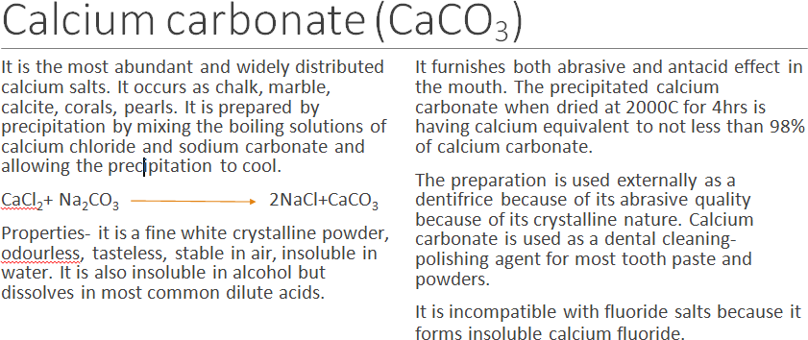

Sodium fluoride (NaF)
Uses-
It is used in dental practice for retarding or preventing dental caries. A 2% solution of sodium fluoride in water may be applied to childrens’ teeth after preliminary cleaning.

It is a constituent of some insecticides. Dose-2.2mg once a day
Cements and fillers
Dental cements are used to temporarily cover protect areas that have undergo operation as in dental surgery.
The cementing material is applied as a paste which gets hardened in a short while it can be removed by the dentist.
The temporary cement is also medicated usually with eugenol which is antiseptic and local anaesthetic.
The consistency of the cement can be controlled by additives. Noble metals and their alloys are used as permanent filling materials for cavities. Gold and silver find use as permanent filling materials

